Weeks 8 and 9 Assignments

Zoucha, Michael

10/25/2021

#Assignment 6

##   
## Call:  
## lm(formula = earn ~ age, data = heights_df)  
##   
## Residuals:  
## Min 1Q Median 3Q Max   
## -25098 -12622 -3667 6883 177579   
##   
## Coefficients:  
## Estimate Std. Error t value Pr(>|t|)   
## (Intercept) 19041.53 1571.26 12.119 < 2e-16 ***  
## age 99.41 35.46 2.804 0.00514 **   
## ---  
## Signif. codes: 0 '***' 0.001 '**' 0.01 '*' 0.05 '.' 0.1 ' ' 1  
##   
## Residual standard error: 19420 on 1190 degrees of freedom  
## Multiple R-squared: 0.006561, Adjusted R-squared: 0.005727   
## F-statistic: 7.86 on 1 and 1190 DF, p-value: 0.005137

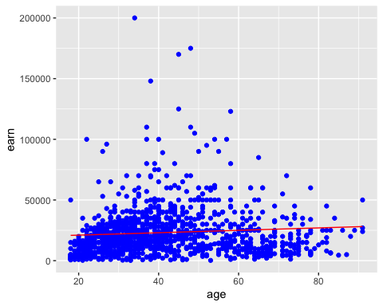 # Assignment 7

##   
## Call:  
## lm(formula = earn ~ height + age + sex + race + ed, data = heights_df)  
##   
## Residuals:  
## Min 1Q Median 3Q Max   
## -39423 -9827 -2208 6157 158723   
##   
## Coefficients:  
## Estimate Std. Error t value Pr(>|t|)   
## (Intercept) -41478.4 12409.4 -3.342 0.000856 ***  
## height 202.5 185.6 1.091 0.275420   
## age 178.3 32.2 5.537 3.78e-08 ***  
## sexmale 10325.6 1424.5 7.249 7.57e-13 ***  
## racehispanic -1414.3 2685.2 -0.527 0.598507   
## raceother 371.0 3837.0 0.097 0.922983   
## racewhite 2432.5 1723.9 1.411 0.158489   
## ed 2768.4 209.9 13.190 < 2e-16 ***  
## ---  
## Signif. codes: 0 '***' 0.001 '**' 0.01 '*' 0.05 '.' 0.1 ' ' 1  
##   
## Residual standard error: 17250 on 1184 degrees of freedom  
## Multiple R-squared: 0.2199, Adjusted R-squared: 0.2153   
## F-statistic: 47.68 on 7 and 1184 DF, p-value: < 2.2e-16